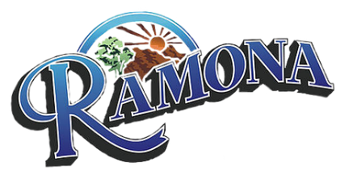
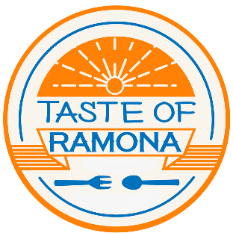
Chamber of Commerce
THE 10th ANNUAL TASTE OF RAMONA
Dear Ramona Business Owner,

The Taste of Ramona 2023 was a huge success but 2024 will be bigger and better!

Saturday, May 18, 2024, from 11:00 am – 5:00 pm will be the date and time for this year’s event. We expect to sell 350 tickets. In the past, most restaurants have had approximately 150 to 200 tasters. Chamber members will have the first opportunity to participate. In addition, all businesses will follow the County guidelines that will be in place.

Space is limited, so please sign up immediately to be included in this year’s Taste. Chamber members will not be charged the $25 registration fee. Non-Chamber members will be asked to donate $25 to cover advertising costs.

The Ramona Chamber of Commerce will take care of all the advertising. We will provide posters, flyers, maps, and tickets. It is to your advantage to promote your business such as offering a coupon or discount to entice a taster to return to your establishment. There will be entertainment at some locations. Once again, there will not be a shuttle service.

If you would like to sponsor the TASTE OF RAMONA 2024, please see the attached form for an opportunity to have your business highlighted during this great event.

It is your responsibility to have adequate staff during the Taste of Ramona, as the Chamber of Commerce cannot provide staff.

Please note, this is just a taste of what you have to offer; you do not need to give an entire plate. A general suggestion would be a 4-ounce serving. Once again, space is limited, so please sign up by Friday, March 29, 2024. We look forward to another great Taste of Ramona.

rccstaff@ramonachamber.com

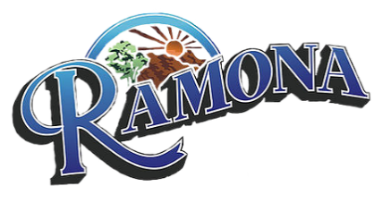
Chamber of Commerce
THE 10th ANNUAL TASTE OF RAMONA
Taste of Ramona Participation Form

Please fill out the information below:
Business name __________________________________________________________________________
Address ___________________________________________________________________________
Contact Name __________________________________________________________________________
Email __________________________________________________________________________
Phone __________________________________________________________________________
Payment Details:
Fee Paid ____________ Chamber Member ________ Restaurant _________ Sponsorship________
Check# ____________ Cash ___________ Online Payment ________________________________
Credit Card ___________________________________ Exp date___________________ CVV ________
Name on Card __________________________________________________________________________
Business Owner/Authorized Representative:
I understand that this form confirms our participation in the 10th Annual Taste of Ramona on May 18, 2024, from 11am to 5pm. I authorize the Ramona Chamber of Commerce to process the above payment which confirms our participation in the Taste of Ramona.

Printed Name: _______________________ Signature: _________________________ Date: ____________

NOTE: Participant application deadline is March 29, 2024

