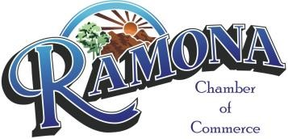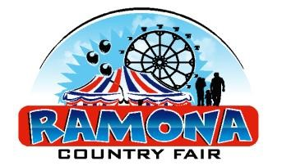
Ramona Country Fair Sponsorship Form

EVENT SPONSORSHIP - $2,500
- Main sponsor billing on all advertisement – print and electronic (social media included)
- (4) banners (supplied by sponsor) displayed in key locations throughout the event
- 12 x 12 fair booth space (3 days) available if desired
- Headline display of company logo and link to company website on www.ramonachamber.com
- Company recognition throughout the event
- (6) Drink Tickets / (6) Unlimited Parking Passes

GOLD SPONSORSHIP - $1,500
- (3) banners (supplied by sponsor) displayed in key locations throughout the event
- 12 x 12 fair booth space (3 days) available if desired
- Prominent display of company logo and link to company website on www.ramonachamber.com
- Inclusion in all fair advertising to include social media
- (4) Drink Tickets / (4) Unlimited Parking Passes

SILVER SPONSORSHIP - $500
- (2) banners (supplied by sponsor) displayed at the event
- Display of company logo and link to company website on www.ramonachamber.com
- Inclusion in local fair advertisement to include social media
- (2) Drink Tickets / (2) Unlimited Parking Passes

BRONZE SPONSORSHIP - $300
- (1) banner (supplied by sponsor) displayed at the event
- Inclusion in local fair advertisement to include social media

Please complete and return to the Ramona Chamber Office

Company Name: ________________________________________________
Your Name: |  | ________________________________________________
Address: |  | ________________________________________________
Phone: |  | ________________________________________________
Website: |  | ________________________________________________
Select One: Event Sponsor Gold Sponsor Silver Sponsor Bronze Sponsor

Mail to (checks payable to): Ramona Chamber of Commerce - 1306 Main St., Ste. 103, Ramona, CA 92065
*We also accept Master Card, Discover, AmEx, and Visa*

