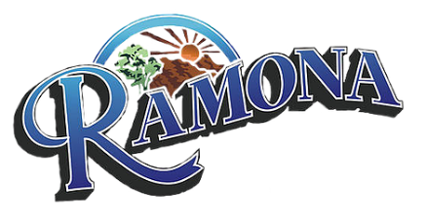
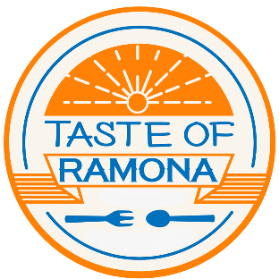
Chamber of Commerce
THE 9th ANNUAL TASTE OF RAMONA
Dear Ramona Business Owner,

The Taste of Ramona 2022 was a huge success but 2023 will be bigger and better!

Saturday, May 20, 2023 from 11:00 am – 5:00 pm will be the date and time for this year’s event. We expect to sell 350 tickets. In the past, most restaurants have had approximately 150 to 200 tasters. Chamber members will have the first opportunity to participate. In addition, all businesses will follow the County guidelines that will be in place.

Space is limited, so please sign up immediately to be included in this year’s Taste. Chamber members will not be charged the $25 registration fee. Non-Chamber members will be asked to donate $25 to cover advertising costs.

The Ramona Chamber of Commerce will take care of all the advertising. We will provide posters, flyers, maps, and tickets. It is to your advantage to promote your business such as offering a coupon or discount to entice a taster to return to your establishment. There will be entertainment at some locations. Once again, there will not be a shuttle service.

If you would like to sponsor the TASTE OF RAMONA 2023, please see the attached form for an opportunity to have your business highlighted during this great event.

It is your responsibility to have adequate staff during the Taste of Ramona, as the Chamber of Commerce cannot provide staff.

Please note, this is just a taste of what you have to offer; you do not need to give an entire plate. A general suggestion would be a 4-ounce serving. Once again, space is limited, so please sign up by Friday, March 31, 2023. We look forward to another great Taste of Ramona.

rccstaff@ramonachamber.com

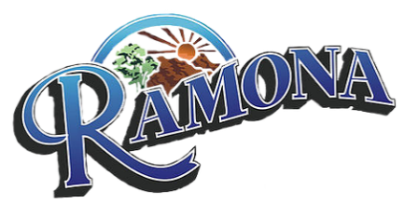
Chamber of Commerce

THE 9TH ANNUAL TASTE OF RAMONA
Sponsorship Opportunities
____________________________________________________________________________________
The Ramona Chamber of Commerce presents the “Taste of Ramona”, a community event filled with lots of food and fun! Participants invite residents and tourists to sample their foods, beverages, and desserts. The event is set to take place Saturday, May 20, 2023, from 11am to 5pm. We are looking for sponsors. This is a great opportunity to HIGHLIGHT your business. Please contact the Ramona Chamber of Commerce at 760-789-1311 for more information on our sponsorship opportunities.

CAVIAR AND CHAMPAGNE SPONSOR: TOP BILLING ON ALL ADVERTISING ---------------------------------- $750
* Business name and logo exposure on ALL Taste of Ramona media and promotions
(Website, Ads, Flyers, Posters, Brochures, Map, etc.)
* Eight Taste of Ramona Tickets

ENTREE SPONSOR: Second Billing ---------------------------------------------------------------------------------------$400
* Business name exposure on ALL media and promotions
(Website, Ads, Flyers, Posters, Brochures, Map, etc.)
* Four Taste of Ramona Tickets

APPETIZER SPONSOR: --------------------------------------------------------------------------------------------------------$250
*Business name with logo on Taste of Ramona Website, Poster and Brochure/ Map
*Two Taste of Ramona Tickets

DESSERT SPONSOR: ------------------------------------------------------------------------------------------------------------$75
*Business name with logo on Brochure/Map

*Please make checks payable to the Ramona Chamber of Commerce*

Chamber of Commerce
THE 9th ANNUAL TASTE OF RAMONA
Taste of Ramona Participation Form

Please fill out the information below:
Business name __________________________________________________________________________
Address ___________________________________________________________________________
Contact Name __________________________________________________________________________
Email __________________________________________________________________________
Phone __________________________________________________________________________
Payment Details:
Fee Paid ____________ Chamber Member ________ Restaurant _________ Sponsorship________
Check# ____________ Cash ___________ Online Payment ________________________________
Credit Card ___________________________________ Exp date___________________ CVV ________
Name on Card __________________________________________________________________________
Business Owner/Authorized Representative:
I understand that this form confirms our participation in the 9th Annual Taste of Ramona on May 20, 2023, from 11am to 5pm. I authorize the Ramona Chamber of Commerce to process the above payment which confirms our participation in the Taste of Ramona.

Printed Name: _______________________ Signature: _________________________ Date: ____________

NOTE: Participant application deadline is March 31, 2023

